Asia-China-Coin-Wang Mang (9-14 CE)

|  |  |
| --- | --- |
| NAME | 新莽六泉, Xīn mǎng liù quán, Xin Mang six springs |
| MATERIAL | Bronze |
| LENGTH | CM/Inches |
| WIDTH | CM/Inchess |
| CONDITION | Rust on the body, Museum quality |

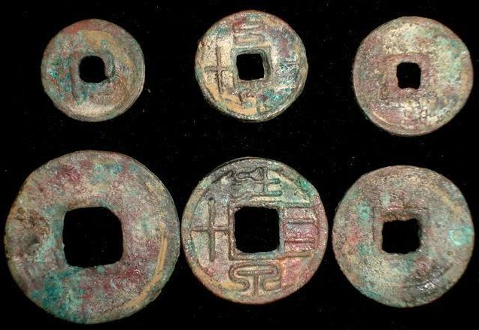

The Six Mang Mang 六泉Coins, left to right. 9-14 CE:(9.14, 9.15, 9.16, 9.1, 9.17, 9.18.

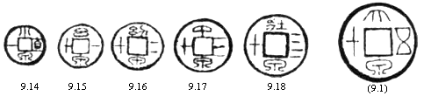

六泉The Six Mang Mang Coins. 9-14 CE.

Harthill no. Weight

9.14 Obv: 小泉宜- XiωQuαn Zhi Yi. Small Coin， Value One. 1 zhu.

9.15 Obv 么泉一十 YωQuαn Yi Shi. Baby Coin， Ten. 3 zhu.

9.16 Obv: 幼泉二十 YouQuαn Er Shi. Juvenile Coin Twenty. 5 zhu.

9.17 Obv: 中泉三十 Zhong Qω凡San Shi. Middle Coin Thirty. 7 zhu.

9.18 Obv: 牡泉四十 ZhuαngQuαn Si Shi. Adult Coin， Forty. 9 zhu.

9.1 Obv: 大泉五十 DαQuan Wu Shi. Large Coin， Fifty. 12 zhu

Wang Mang (7-23 CE) Wang Mang, a nephew of the Dowager Empress Wang, was appointed Regent over the two year­old Ruzi in AD 7. In AD 9, he usurped the throne, and founded the *Xin* Dynasty. Regarded by some as a visionary reformer and proto-communist who nationalized land and redistributed it among the peasants, and by others as a bungling tyrant, he introduced a number of currency re­forms. The first reform, in AD 7, retained the *Wu Zhu* coin, but reintroduced two versions of the knife money, and a *Da Quan Wu Shi* coin with a nominal value of fifty *Wu Zhu.* Between AD 9 and 10 he introduced an impossibly complex system involving tortoise shell, cowries. gold, silver, round copper coins, and a reintroduction of the spade money. According to the *History of Han:*

The people became bewildered and confused, and these coins did not circulate. They secretly used Wu Zhu coins for their purchases. Wang Mang was very concerned at this and issued the following decree: Those who dare to oppose the court system and those who dare to use Wu Zhus surreptitiously to deceive the peo­ple and equally the spirits will all be exiled to the Four Frontiers and be at the mercy of devils and demons. The result of this was that trade and agriculture languished, and food became scarce. People went about crying in the markets and the highways, the numbers of sufferers being untold. Wang Mang, a nephew of the Dowager Empress Wang, was appointed Regent over the two-year-old Ruzi in AD 7. In AD 9, he usurped the throne, and founded the Xin Dynasty. Regarded by some as a visionary reformer and proto-communist who nationalised land and redistributed it among the peasants, and by others as a bungling tyrant, he introduced a number of currency re­forms. The first reform, in AD 7, retained the Wu Zhu coin, but reintroduced two versions of the knife money, and a Da Quan Wu Shi coin with a nominal value of fifty Wu Zhu. Between AD 9 and 10 he introduced an impossibly complex system involving tortoise shell, cowries. gold, silver, round copper coins, and a reintroduction ofthe spade money. According to the History of Han:

The people became bewildered and confused, and these coins did not circulate. They secretly used Wu Zhu coins for their purchases. Wang Mang was very concerned at this and issued the following decree: Those who dare to oppose the court system and those who dare to use Wu Zhus surreptitiously to deceive the peo­ple and equally the spirits will all be exiled to the Four Frontiers and be at the mercy of devils and demons. The result of this was that trade and agriculture languished, and food became scarce. People went about crying in the markets and the highways, the numbers of sufferers being untold.

In AD 14, all these tokens were abolished, and replaced by another type of knife coin and new round coins. Eventually, Wang Mang's unsuccessful reforms provoked rebellion, and he was assassinated by rebels in 23 CE (see Harthill )

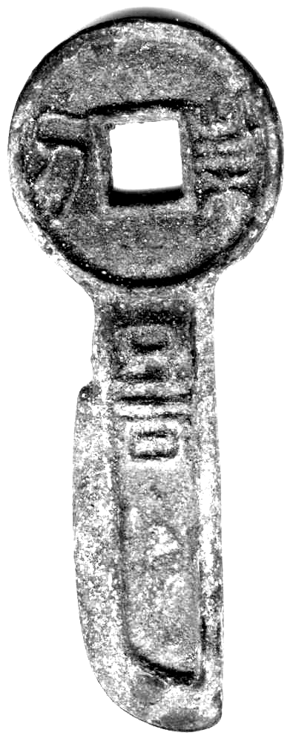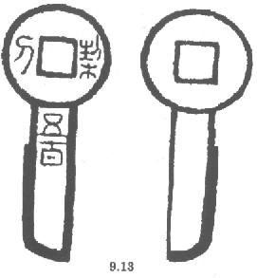

Wang Mang 六泉, Engraved Knife Coin Five Hundred (Harthill 9.13) Obv:契(=刻)刀五百, Qì (=Kè) dāo wǔ bǎi,("Mutual covenant" (= engraved) "knife five hundred".

Coin,Round shape with a Square hole,life tool.It plays an very important part in chinese history.It had been used since the Qin Nation in early Spring and Autumn Period.Such a long time.People use it to get things they need,government use it to steady their rule...

新莽六泉,6 coin in the Xin Mang Period, Late Western Han Dynasty.Four ancient chinese words on the face,no words on the back.Very good calligraphy called"XuanZhenZhuan".And at the same time,these coins should be called as the best coins in chinese history.

This collection is a SET of very rare Bronze Round Coins.Beautiful color with proper size.Well worth your collecting.

